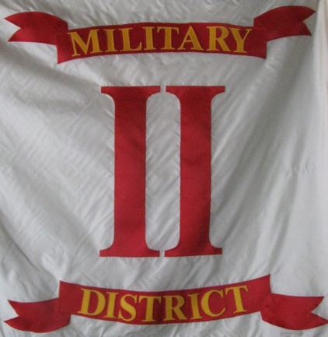
Headquarters
Commander Second Military District Sons Veterans Reserve
104 Mullbury Place
Lynchburg, Virginia 24502
(434)385-7283 or (540)797-7754
email: oscmbb64@msn.com

O

Unit Commanders and Adjutants,
I wish to thank everyone for the expeditious manner in which you have submitted your annual reports and dues payments. While we still have a couple of outstanding commission request; we come to the end of March in very good shape. I want you to know that I am grateful to each of you because through your efforts, I can report that all the Second Military District Unit EIN's, Unit Annual Strength Reports, and Annual Unit Applications have been received by the district and forwarded to the National Adjutant.
I thank each of the unit Commanders and Adjutants of the Second Military District for their commitment to the SVR and say to each of you "WELL DONE" for your efforts in reaching the districts goal; to have our reports in on time.
I also wish to thank the Second Military District Adjutant 1st LT. Justin Dorsey for his dedication in ensuring the reports were collected and forwarded. His diligence and dedication were a significant factor in our successful completion of these annual tasks.

Mark R. Day

Commander 2nd Military District, SVR

