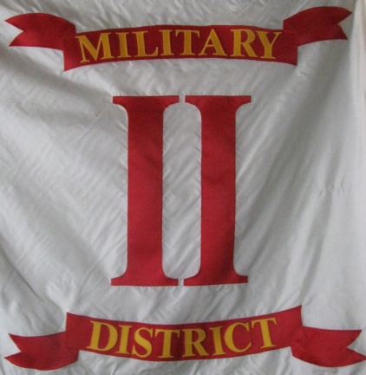
Headquarters
Commander Second Military District Sons Veterans Reserve
104 Mullbury Place
Lynchburg, Virginia 24502
(434)385-7283 or (540)797-7754
email: oscmbb64@msn.com

O

Second Military District General Order 3-2012
Unit Commanders and Adjutants,
We are quickly approaching the end of the year, I remind you that annual reports will be due at the end of December. Unit Commanders and Adjutants should be in the process of completing the reports and sending them to the district adjutant. Please take action to complete these required reports and be sure to file you 990N with the IRS.

Mark R. Day, Major
Commander 2nd Military District, SVR

