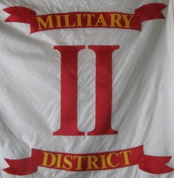
Headquarters' Second Military District, Sons Veterans Reserve
104 Mullbury Place
Lynchburg, Virginia 24502
(434)-385-7283
oscmbb64@msn.com
Brother Commanders and Adjutants,
Subj: 2nd Military District General Order 02-2012
Earlier today, I received an email containing g a National Counselors opinion, issued by PNC in C James Pahl, in reference to an IRS ruling sent to the National SUVCW organization dated 5 April 2012.
As National Counselor PNC in C Pahl issued the following opinion:
"Based upon this letter, it is my formal opinion that gifts made to the Departments and Camps of this Order, including all levels of the Sons of Veterans Reserve are NOT tax deductable on the part of the donor. If anyone has made a donation to any Camp or Department (or any unit of the SVR) where a receipt was issued by the Order, where it is suspected the donor may be desiring the receipt for the purpose of deducting the donation on their personal income tax return within the last three tax years, the donor needs to be made aware of this change in policy on the part of the IRS, so the donor may consult with their tax professional as to the possibility of needing to file an amended income tax return."
"It is my opinion that each Camp and Department of the Order, including all levels of the Sons of Veterans Reserve, need to place an affirmative statement on their respective web site, that any donation to the subordinate unit of the Sons of Union Veterans is not tax deductable."
As Commander of the 2nd Military District, SVR I hereby order:
1. That each Unit Commander and Adjutant inform their membership of this ruling.
2. That each Unit Commander and Adjutant cease providing tax exemption letters to individuals, both member and non-member, who donate either money or materials in kind to their SVR units.
In Fraternity, Charity and Loyalty
Mark R. Day, Captain
Commander 2nd Military District, SVR

