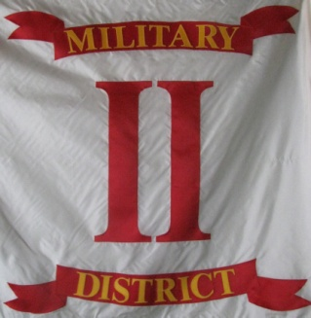
Headquarters
Commander 2nd Military District, SVR
104 Mullbury Place
Lynchburg, VA, 24502
434-385-7283

Second Military District Order 1-2012

Brothers and Comrades in the SVR,
It is my sad duty to inform the brothers of the 2nd Military District that we have lost one of our most active members. Early this morning I received word that Robert Hileman Jr., commander of the 110th PA, SVR and commander of the Department of PA's camp #89, had passed away during the night. Brother Bob was a true gentleman and he was dedicated to the cause of honoring and remembering the fallen men of the Civil War.
I have forwarded my personal condolences to his family and asked that they provide me with the details of his burial arrangements. I will forward that information to you as soon as possible.
I request that all units of the 2nd Military District honor the loyal service of Brother Robert Hileman by observing a moment of silence at their next unit meeting and by wearing a black mourning ribbon on their uniforms until the 20th day of March 2012.

Mark R. Day, Captain
Commander 2nd Military District, SVR

