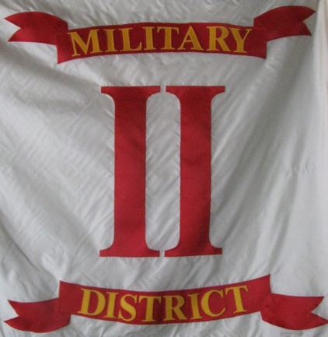
Headquarters
Commander Second Military District Sons Veterans Reserve
104 Mullbury Place
Lynchburg, Virginia 24502
(434)385-7283 or (540)797-7754
email: oscmbb64@msn.com

Second Military District General Order 4-2012
It has come to my attention that not all units are familiar with the procedures for submitting award recommendations to the District for consideration. To assist unit commanders, I am issuing this clarification of the policies and procedures to be used by units of the Second Military District. The policy's described below are in accordance with Article X of the SVR Regulations Manual and shall be the policies of the Second Military District unless they are modified or changed by the Military Affairs Committee or order of the National Commander.
Please review the content of this order and feel free to submit you recommendations. I want to see the men of the Second Military District receive full credit for their efforts.
The National Commander has established the following awards:
A. Meritorious Service Medal: A silver star worn on the SVR membership badge may be awarded to those members who demonstrate outstanding meritorious service specifically on behalf of the SVR. It may also be awarded to those members who recruit a minimum of ten (10) new members into the SVR in a calendar year.

B. Distinguished Service Medal: A gold star worn on the SVR membership badge may be awarded to those members who demonstrate exceptional service of duty that reflects upon the accomplishments and prestige of the SUVCW and SVR on a national scale. Recognition shall be for extremely difficult duty, which clearly aids the SVR in furthering the SUVCW mission objectives.

C. SVR Unit Citation: This may be awarded to those units for being exceptionally meritorious in promoting the goals and objectives of the SVR and the SUVCW which clearly sets the unit above and apart from similar units. The SVR Unit Citation is a white oval shaped enamel badge bearing the SVR logo which is worn over the left breast of the wearer above other badges and medals being worn. Subsequent awards to the same unit will be awarded a bronze star for placement on the ribbon of the Sons of Veterans Reserve membership badge.
Nominations procedures for personal and unit awards are as follows:

A. The Second Military District shall establish an Awards Board (comprised of District Staff Officers) to review nominations for personal and unit awards.

B. Nominations from the individual units of the Second Military District shall be forwarded, in writing, to the Second Military District Adjutant containing a narrative justifying the member’s/unit’s achievements no later than 1 August of each year. Any SUVCW member having knowledge of an act of service meriting recognition may initiate a recommendation for an award.

C. All narratives submitted to the Second Military District Awards Board should be specific as to include dates, places and facts relating to achievement of service. The narrative must clearly portray how the Unit’s or individual’s achievements meet or exceed the criteria set forth above.

D. The Second Military District Awards Boards shall record all nominations within their district and submit their nominations to the Deputy Commander, SVR, no later than 1 September of each year.

E. The Deputy Commander, SVR, will convene the National Awards Board (comprised of the General Staff), review all nominations submitted, and select those most qualified to receive awards.

F. All awards will be presented by the Commanding Officer, SVR or his representative, at the annual Remembrance Day SVR breakfast in Gettysburg, Pennsylvania.

Other Awards

The following awards may be awarded by District Commanders and Commanding Officers of SVR Units for those individuals that do not meet the criteria for the Meritorious Service Medal or the Distinguished Service Medal who promote the principles of the SUVCW and SVR and who demonstrate sustained superior performance in their duties:

A Commanding Officers of SVR units: Letter of Appreciation. (Local Unit Commander)

B. District Commanders: District Commander Letter of Appreciation and Letter of
Commendation. (Second Military District Commander)

Mark R. Day, Major
Commander 2nd Military District, SVR

