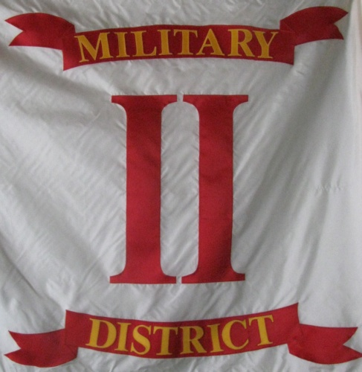
Headquarters 2nd Military District, SVR
104 Mullbury Place
Lynchburg, Virginia, 24502
oscmbb64@msn.com
434-385-7283
540-797-7754

Brothers of the 2nd Military District,

As we celebrate Memorial Day this weekend It is my profound hope, that each and every member, of the 2nd Military District, will be involved in an activity dedicated to the memory of those who have fallen in battle throughout the long history of our nation. We have a solemn duty to ensure that our friends, our children, and our neighbors children; never forget the sacrifices made by these men; in order to ensure the success t of the great American experiment in democracy begun by the founders. Of course our particular focus should and does lie with the remembrance of the "Boys in Blue" who fought to preserve this nation and set all men free. Our birth right is their legacy for without their sacrifice the America we know would not exist. I ask that each of you do your part in keeping their memory green, to ensure that their monuments are well tended, and the testimony they left us unbroken by the forces of time. The debt of gratitude we owe them will never be repaid by any single generation but must be continually repaid by every generation to come.
My wish for each of you is good weather, the comfort of family, and the best of health over the holiday weekend. Be safe and enjoy the beauty of each day.

Mark R. Day, Captain
Commander 2nd Military District, SVR

